**ENGL 758D:**

**The Speculative Situation**

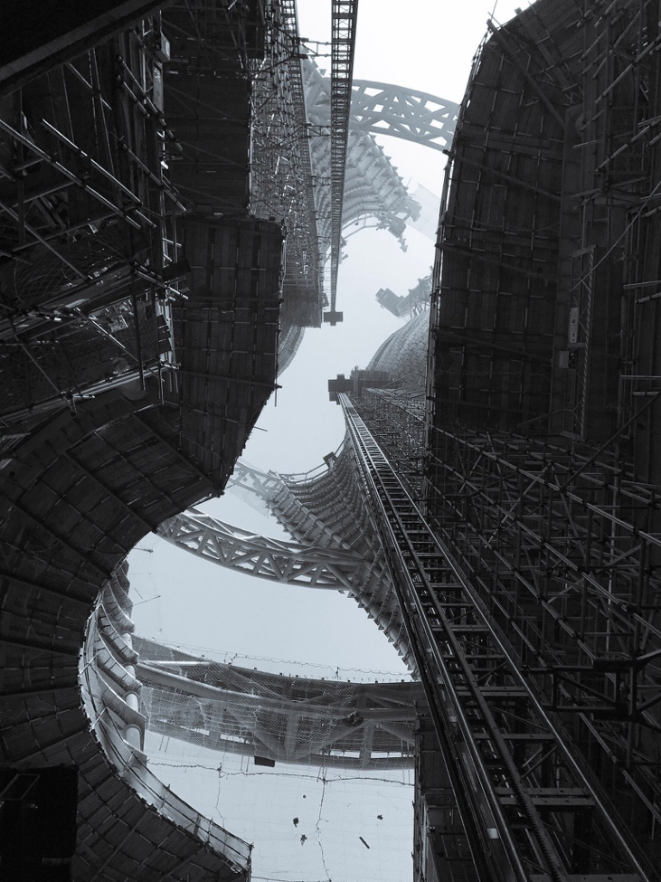[1]

**Fall 2017**

**University of Maryland**

**Matthew Kirschenbaum**

Tuesdays, 6:30 - 9:00pm (Tawes 3252)

Office Hours: by appointment (email [mgk@umd.edu](mailto:mgk@umd.edu))

**Introduction**

For more than a generation now, literary and cultural studies have operated amid the horizon of a historical turn—a sweeping deference to the almost palpable specificity of an acknowledged past, this deference governing projects across all major genres and periods. Increasingly, however, we see signs of what a 2011 volume of Continental philosophy named the *speculative* turn—or better, perhaps, acknowledging the Latin root *speculat-* (“to observe from a vantage point”), a speculative *situation*. Yet that situation is not one of philosophy only. “Speculation” is widely (if nebulously) understood as the root cause of the turmoil in the global financial markets of 2008. The speculative equally calls into view the data-driven forecasting whose scenarios of what-might-be have come to inform our daily experience of everything from the outcomes of elections to tomorrow’s weather. In literature, meanwhile, speculative fiction has emerged to name an increasingly prominent mode of writing that encompasses aspects of science fiction, environmentalism, and political and social critique.

To constitute or construe this speculative situation for ourselves we will initially read deeply into the new speculative realist philosophy and accompanying—sometimes antagonizing—discourses such as the New Materialism, vitalism, feminist science studies, and object-oriented ontology. This reading will take up roughly the first half of the course. We will then look at a sampling of speculative fiction, including Octavia Butler’s *The Parable of the Sower* and Kim Stanley Robinson’s *New York 2140*, as well as selections from popular non-fiction works like Alan Weisman’s *The World Without Us* and Nate Silver’s *The Signal and the Noise*. And we will revisit the financial speculation of a decade ago and consider the politics of occupying its aftermath. Other key authors (roughly in order of appearance) will include Quentin Meillassoux, Graham Harman, Levi Bryant, Tim Morton, Steve Shaviro, Ian Bogost, Elizabeth Grosz, Jane Bennett, Sara Ahmed, Rebekah Sheldon, Karen Barad, Donna Haraway, Fredric Jameson, Alexis Lothian, Kari Kraus, Andrew Blum, J. R. Carpenter, Katherine Hayles, Nick Srnicek, Benjamin Bratton, and the anonymous collective known as Uncertain Commons, among others, as well as Kant, Heidegger, and Deleuze and Guattari.

Throughout we will seek to foster awareness of the *non-inevitability* of the historical turn in literary and cultural studies, while also asking what is at stake in the current project of the speculative. History, nature, systems (and networks), and worlding will all be constant themes, as will what possibilities remain for acting, or simply living. The course should therefore be of interest to those working in any historical period, and to all citizens of a world that is still—however tenuously—with us.

**Books**

Open access and required for download:

* Levi Bryant, Nick Srnicek, Graham Harman, [*The Speculative Turn*](https://www.re-press.org/book-files/OA_Version_Speculative_Turn_9780980668346.pdf) (re.press, 2011)

All of the following may be sourced from any quality bookseller; they should run you about $100 new.

* Octavia Butler, *The Parable of the Sower* (Grand Central, 2000)
* J.R. Carpenter, *The Gathering Cloud* (Uniformbooks, 2017); not available from Amazon
* Quentin Meillassoux, *After Finitude* (Bloomsbury, 2006)
* Nate Silver, *The Signal and the Noise* (Penguin, 2015)
* Kim Stanley Robinson, *New York 2140* (Orbit, 2017)
* Uncertain Commons, *Speculate This!* (Duke UP, 2013); available as an ebook only
* Alan Weisman, *The World Without Us* (Picador, 2008)

Additionally, purchasing any or all of the following is recommended, as we will be reading multiple essays from each and you may prefer the book in hand to PDFs.

* Levi Bryant, Nick Srnicek, Graham Harman, *The Speculative Turn* (re.press, 2011)
* Diana Coole and Samantha Frost, eds. *New Materialisms: Ontology, Agency, and Politics* (Duke UP, 2010)
* Richard Grusin, ed. *The Nonhuman Turn* (Minnesota UP, 2015)

**Grading and Requirements**

The distribution of requirements and their percentage of your final grade is as follows:

* Presentation: 20%
* Participation: 30%
* Paper/Project: 50%

The presentation will take the form of oral remarks in a single class meeting, accompanied by discussion questions and discussion leading for the remainder of the session. I will distribute further guidelines and expectations.

Participation includes class participation as well contributions to the discussion forum on ELMS. At least three (3) times during the semester you must post a 500-word (minimum) contribution to the ELMS discussion forum that takes one of the following forms:

* *Cosplay!* Impersonate the style and modus of a single individual author. Write something they would write as they would write it, as best you are able. (This is an earnest exercise, not parody.)
* *Takedown!* Of a specific text by a single individual. Must be based in close reading and critical argumentation.
* *Kinship!* Link together two or more seemingly unrelated texts by two or more individuals. Must be based in close reading and critical argumentation.
* *Curation!* Trace the threads of a pre-existing conversation by gathering citations, links, and embedding media. Must be accompanied by your own critical narrative—that is, show *and* tell.
* *Carpentry!* Make something; make some *thing* (à la Bogost), and document it.

At least one must be posted before Sept. 26; at least two must be posted before Oct. 24. At least one must be posted *after* Oct. 24. These will not be graded as such, but if any are missing or—in my estimation—are substantially lacking in quality of effort there will be a direct impact on the participation portion of your grade. Commenting others’ responses is strongly encouraged, and will positively influence your participation grade.

The paper or project is the traditional deliverable for a 700-level course, and should be discussed with me well in advance of its due date, which is Friday, December 15. (15-20 pages is typical for a paper at this level.)

**Policies**

This course will operate according to the [University of Maryland Graduate School’s policies](https://www.gradschool.umd.edu/policies). It is your responsibility to familiarize yourself with those policies and to ask me if you have a question about any of them or how they apply to this course. Some additional points follow.

*Diversity*:The University of Maryland values the diversity of its student body. Along with the University, I am committed to providing a classroom atmosphere that encourages the equitable participation of all students regardless of age, disability, ethnicity, gender, national origin, race, religion, or sexual orientation. Potential devaluation of students in the classroom that can occur by reference to demeaning stereotypes of any group and/or overlooking the contributions of a particular group to the topic under discussion is inappropriate.

*Academic Integrity:* The University is one of a small number of universities with a student-administered [Code of Academic Integrity](http://www.shc.umd.edu/code.html) and an [Honor Pledge](http://www.shc.umd.edu/code.html#honor_pledge). The Code prohibits students from cheating on exams, plagiarizing papers, submitting the same paper for credit in two courses without authorization, buying papers, submitting fraudulent documents, and forging signatures. *All students in this class are expected to abide by the terms of this code at all times and are assumed to be operating under its strictures.* More information is available here: <http://www.shc.umd.edu/SHC/Default.aspx>.

*Attendance:*University policy excuses the absences of students for illness (self or dependent), religious observances, required military service, participation in University activities at the request of University authorities, and extreme extenuating circumstances beyond the student’s control. That said, you are expected to be present for class meetings—remember, missing a single graduate class is the equivalent of missing a full week of undergraduate classes. *Note that we are meeting on both Halloween and the Tuesday before Thanksgiving!* Unexcused absences will have a direct impact on your participation grade: if you’re not here, you’re not participating. If you accrue multiple absences, either excused or unexcused, I reserve the option to request a conversation with you in the presence of the Director of Graduate Studies to assess your circumstances in light of the commitments necessary for graduate work.

*Religious Observances:*The University of Maryland policy “Assignments and Attendance on Dates of Religious Observance” states that students should not be penalized in any way for participation in religious observances and that, whenever feasible, they be allowed to make up academic assignments that are missed due to such absences. *It is the student's responsibility to inform the instructor of any intended absences or need for other accommodation for religious observances* *in advance*.

*Disabilities:*The University will provide appropriate accommodations for students with documented disabilities. In order to ascertain what accommodations may need to be provided, students with disabilities should inform the instructors of their needs at the beginning of the semester. They will make arrangements with the student to determine and implement appropriate academic accommodations. Students should also register with Disability Support Services (DSS) <http://www.counseling.umd.edu/DSS> (301-314-7682).

*ELMS:*The class is listed on ELMS. We will use the ELMS site to distribute readings and host our online discussion forum. Course news and announcements will also be distributed through ELMS. Please make sure you have a current email address recorded in ELMS and that you check that address regularly; and that your spam filter is not blocking ELMS messages. *You will be held responsible for any electronic announcement 24 hours after it has been distributed.*

**About the Readings**

With some few exceptions, I have avoided assigning overviews and introductions, alluring as these can be in their promise of synthesis. We will treat these texts as artifacts—which is to say, *things*, things to think with—and not as authorities. That being said, for those looking for an introduction, overview, or catch-me-up, Graham Harman’s blog posting “[brief SR/OOO tutorial](https://doctorzamalek2.wordpress.com/2010/07/23/brief-srooo-tutorial/)” is indispensable, as is Steven Shaviro’s “[Speculative Realism: A Primer](http://terremoto.mx/article/speculative-realism-a-primer/)”; beyond these, I recommend any or all of the following: Bryant, Srnicek, and Harman’s introduction to *The Speculative Turn*; Ian Bogost’s first chapter in *Alien Phenomenology* *or What It’s Like to Be a Thing* (Minnesota UP, 2012); Shaviro’s introduction in *The Universe of Things: On Speculative Realism* (Minnesota UP, 2014); Robin Mackay’s [introduction](https://www.urbanomic.com/wp-content/uploads/2015/01/Collapse_2_Introduction.pdf) to *Collapse* vol. 2; Richard Grusin’s introduction to his *The Nonhuman Turn* volume; Diana Coole and Samantha Frost’s introduction to their *New Materialisms* volume; and Katherine Behar’s introduction to her *Object-Oriented Feminism* volume (Minnesota UP, 2016).

One of the notable features of the speculative realist debates has been the extent to which their participants have been self-conscious of engaging one another in the academic equivalent of a real-time conversation. Sometimes this takes the form of essays framed as “A Response to . . .”; other times the dialogue is just barely submerged in the citations. As you read it will be important to keep track of individuals and their positions vis-à-vis one another. Take notes, make a chart, build a diorama—whatever works for you. You should have the feeling of walking in on the middle of an intense and ongoing conversation, and gradually making some sense of what the conversation is about, who the participants are, how they align with one another, who wants to give who side-eye or throw shade, and what are perceived as the conversation’s ultimate stakes. (The *Kinship!* and *Takedown!* response options are both suited for this.) I’ve also made an effort to assign multiple pieces from key thinkers, often spread across different weeks. Their voices will thus drift in and out the room, growing more familiar as the days grow colder, but also maybe stranger as the night comes sooner.

Likewise, much of the ferment of the speculative realist debate has unfolded online. Googling many of these authors will therefore turn up a multitude of blog entries, Twitter accounts, reviews, take-downs, appreciations, audio or video of lectures and interviews, and more. Engage with this material as you see fit and pass your finds on to the rest of us (this is what the responses *Curation!* option is for).

For journals of the speculative realist movement, [*Collapse*](https://www.urbanomic.com/series/collapse/) is terra firma; see especially volumes 2 and 3. I have a complete run in my office which you may consult.

**Reading Schedule**

*Readings with an asterisk* are available as PDFs from the Files folder on ELMS; those marked with a + are to be found in* The Speculative Turn*. Other abbreviations denote items from* The Nonhuman TurnNHT *and the* New MaterialsmsNM *volumes, though these will also be available as PDFs on ELMS if you choose not to buy those books. When readings are online, they are linked. If none of the preceding, then the reading is one of the complete books which you must buy.*

**Aug 29. The Speculative Situation:** Uncertain Commons, *Speculate This!*

**Sept 5. Historicism, a Quick Casebook:** Carlo Ginzburg, “Clues: Roots of an Evidentiary Paradigm”*; J. Hillis Miller, “The Triumph of Theory, the Resistance to Reading, and the Question of the Material Base”*; Stephan Greenblatt and Catherine Gallagher, “The Touch of the Real”*; Alan Liu, “Local Transcendence”*; Joseph North, from *Literary Criticism: A Concise Political History* (Introduction, chapter 3)*

**Sept 12. Correlationism:** Quentin Meillassoux, *After Finitude*; Immanuel Kant, from *Critique of Pure Reason*\*; Peter Hallward, “Anything is Possible”+; Nathan Brown, “The Speculative and the Specific”+

**Sept 19. Objects and Ontics:** Graham Harman, “On the Undermining of Objects”+; Ian Hamilton Grant, “Mining Conditions”+; Levi Bryant, “The Ontic Principle”+; Steve Shaviro, “The Absolute Volcano”+; Graham Harman, “Response to Shaviro”+

**Sept 26. Tools, Things, and Stuff:** Martin Heidegger, from *Being and Time\**; Bill Brown, “Thing Theory”; Elizabeth Grosz, “The Thing”; Graham Harman, “The Well-Wrought Broken Hammer”*; Ian Bogost, “The Aesthetics of Philosophical Carpentry”*NHT; Irina Aristarkhova, “A Feminist Object”*; Kari Kraus, “Finding Fault Lines: An Approach to Speculative Design”*; First response due

**Oct 3. Assemblages, Hyperobjects, and Vitalism:** Gilles Deleuze and Felix Guattari, from *A Thousand Plateaus*; Timothy Morton, “Here Comes Everything”*; Morton, “[They Are Here](https://vimeo.com/41887863)” (Vimeo video); Jane Bennett, “Systems and Things”*NHT; Bennett, “A Vitalist Stopover on the Way to a New Materialism”*NM

**Oct 10. New Materialisms and Other Entanglements:** Rebekah Sheldon, “Form/Matter/Chora”*NHT; Elizabeth Grosz, “Feminism, Materialism, Freedom”*NM; Sara Ahmed, “Orientation Matters”*NM; Karen Barad, from *Meeting the Universe Halfway* (chapter 4)*

**Oct 17. Archaeology of Apocalypse:** Octavia Butler, *Parable of the Sower;* Fredric Jameson, from *Archaeologies of the Future*\*

**Oct 24. Speculative Lives:** Alexis Lothian and Jayna Brown, [Speculative Life](https://socialtextjournal.org/periscope_topic/speculative_life/) cluster in *Social Text* (all entries); Lothian, from *Old Futures: Speculative Ficiton and Queer Possibility* (introduction and chapter 1)*; Donna Haraway, “A Cyborg Manifesto”*; Second response due

**Oct 31. The Speculative City I:** Kim Stanley Robinson, *New York 2140* (parts I-IV); Benjamin Bratton, from *The Stack* (“Earth Layer”)*

**Nov 7.** **The Speculative Planet:** Alan Weisman, *The World Without Us* (at least chapters 1-8, 10, 15, 18, 19); Haraway, from *Staying with the Trouble* (chapter 2)*; Morton, from *Dark Ecology* (“First Thread”)*

**Nov 14.** **The Speculative City II:** Robinson, *New York 2140* (parts V-VIII); Bratton, from *The Stack*\* (“City Layer”)

**Nov 21.** **The Speculation Industry:** Nate Silver, from *The Signal and the Noise* (at least chapters 1-4, 11, 12); Andrew Blum, from *The Weather Machine* (chapters TBA)*; Kraus, “[Conjectural Criticism: Computing Past and Future Texts](http://www.digitalhumanities.org/dhq/vol/3/4/000069/000069.html)”

**Nov 28. Games Without Frontiers:** Cathy O’Neil, from *Weapons of Math Destruction*\*; Play [Speculat1on](http://speculat1on.net/); Explore [Nexus X: An Alternate Archive](http://criticalinquiry.uchicago.edu/nexus_x_an_alternate_archive/); Katherine Hayles, Patrick Jagoda, and Patrick LeMieux, “Speculation: Financial Games and Derivative Worlding in a Transmedia Era”*; Nick Srnicek, from *Platform Capitalism* (chapter 2)*

**Dec 5.** **Tomorrow and Tomorrow and Tomorrow:** J.R. Carpenter, *The Gathering Cloud* (see also the [web version](http://luckysoap.com/thegatheringcloud/)); Bratton, from *The Stack* (“The Stack to Come”);Third response due

Papers/Projects Due: Friday, Dec. 15, 5:00pm. No exceptions, no extensions.

1. Image: Leeza Soho skyscraper under construction, Beijong. Photo by Satoshi Ohashi. Twitter: https://twitter.com/tdDaz/status/900865694954385408.